# **Details about 2WD V8 Smart Car Chassis Robot Tracking Coded Disc**

$17.22

<http://www.ebay.com/itm/361195314737?_trksid=p2060778.m1438.l2649&ssPageName=STRK%3AMEBIDX%3AIT>

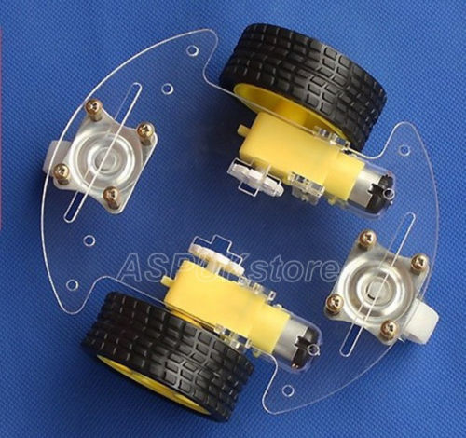

# **Details about 1Set 2WD Mini Round Double-Deck Smart Robot Car Chassis DIY Kit for Arduino**

$10.30 + $1.59 shipping

<http://www.ebay.com/itm/281765218354?_trksid=p2060353.m1438.l2649&ssPageName=STRK%3AMEBIDX%3AIT>

$13.85

<http://www.ebay.com/itm/271630961986?_trksid=p2060778.m1438.l2649&ssPageName=STRK%3AMEBIDX%3AIT>

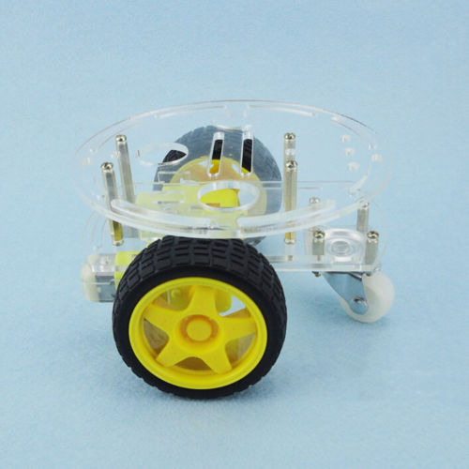

# **Details about NICE Motor Smart Robot Car Chassis Kits Speed Encoder For Arduino USFM FM**

$9.12 + $1.31 shipping

<http://www.ebay.com/itm/291382416507?_trksid=p2060778.m1438.l2649&ssPageName=STRK%3AMEBIDX%3AIT>

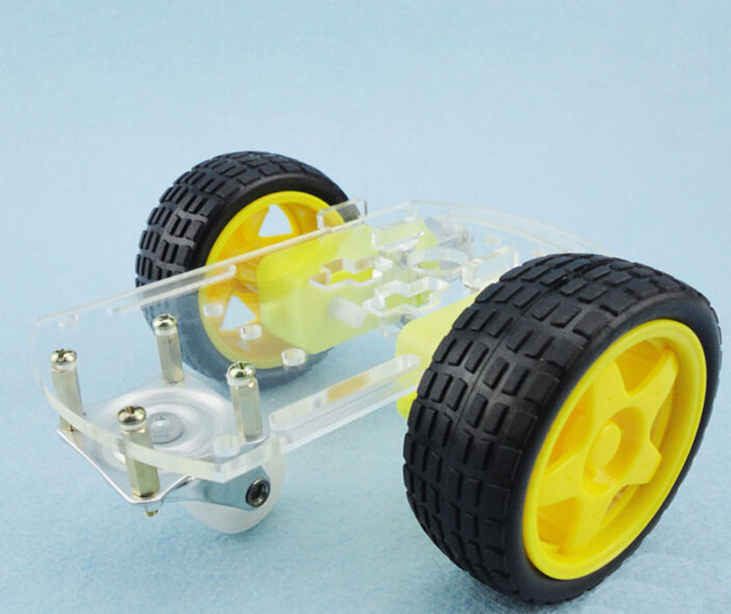

Robot Kit:

# **Details about Arduino robot kit wireless control 2wheel**

$79.90

<http://www.ebay.com/itm/251547870725?_trksid=p2060778.m1438.l2649&ssPageName=STRK%3AMEBIDX%3AIT>

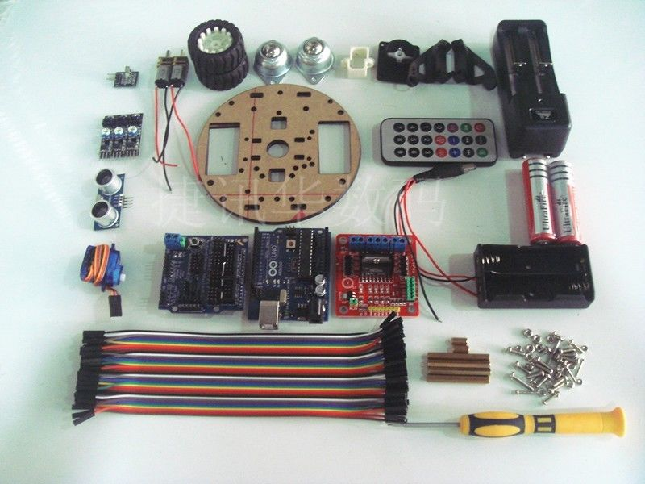

# **Magician Chassis**

$15.00 + $6.10 shipping

<http://www.ebay.com/itm/201396210379?_trksid=p2060353.m1438.l2649&ssPageName=STRK%3AMEBIDX%3AIT>

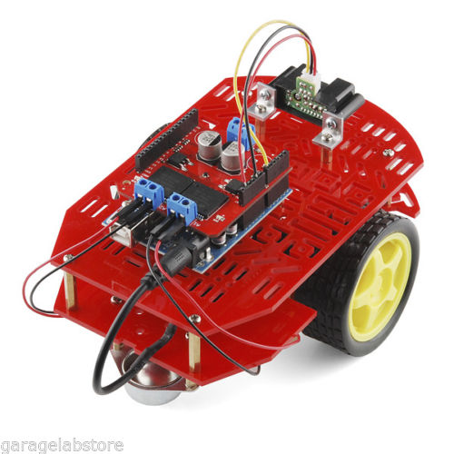

# **Smart Car 4WD Robot With Suspension Chassis And Kit (NEW, USA, Arduino Control)**

$38.90

<http://www.ebay.com/itm/261708228061?_trksid=p2060353.m1438.l2649&ssPageName=STRK%3AMEBIDX%3AIT>

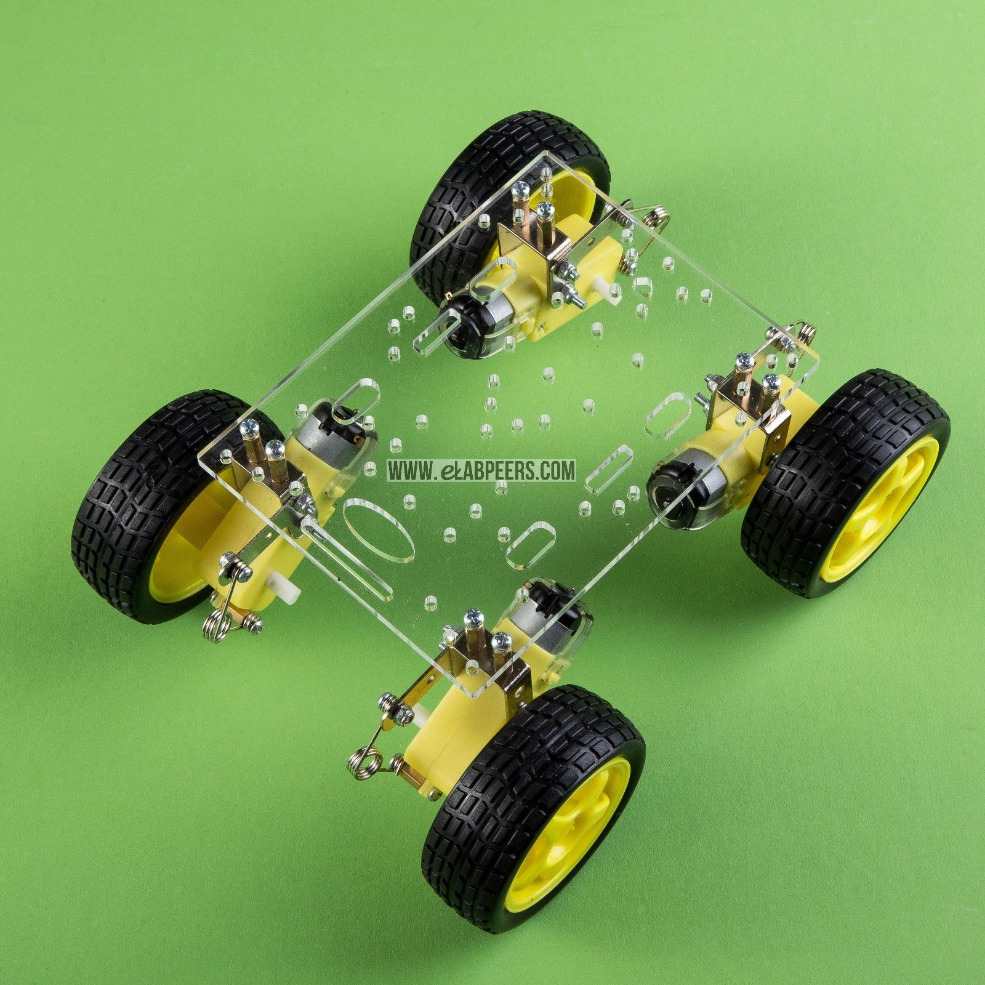

# **Steering engine 4 wheel 2 Motor Smart Robot Car Chassis kits DIY For Arduino**

$29.90

<http://www.ebay.com/itm/271954109365?_trksid=p2060353.m1438.l2649&ssPageName=STRK%3AMEBIDX%3AIT>

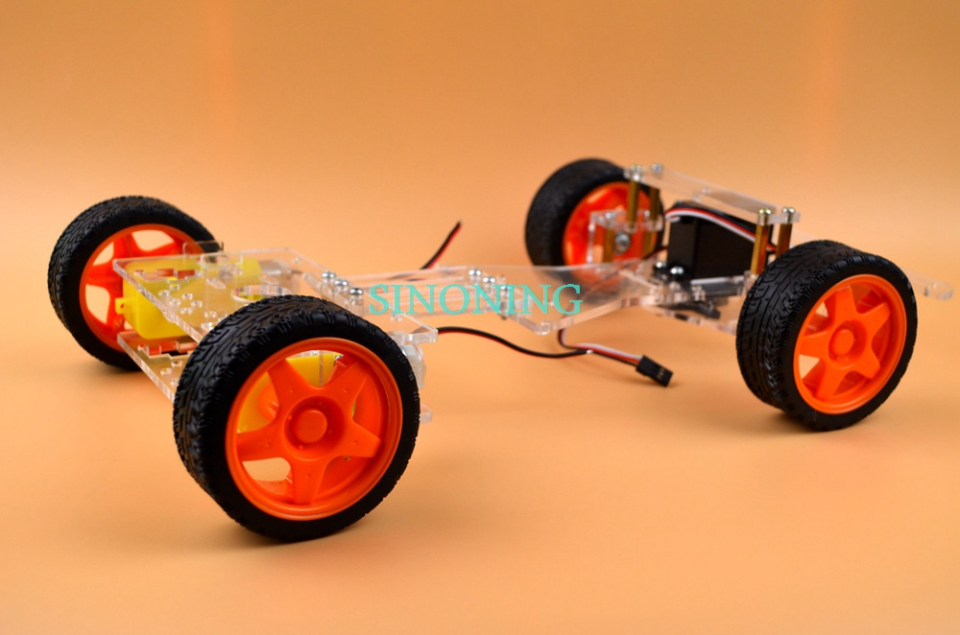

# **2WD Smart Robot Car 3 Layer Acrylic Acrylic Chassis Kits with Speed Encoder**

$17.90

<http://www.ebay.com/itm/271953404861?_trksid=p2060353.m1438.l2649&ssPageName=STRK%3AMEBIDX%3AIT>

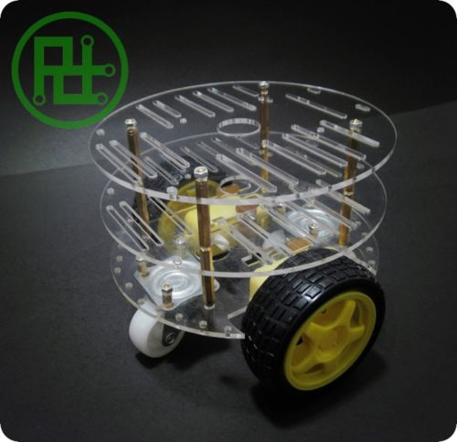

# **Multifunction Bluetooth Controlled Robot Smart Car Kits For Arduino**

$86.63

<http://www.ebay.com/itm/New-Multifunction-Bluetooth-Controlled-Robot-Smart-Car-Kits-For-Arduino-/121661343150?hash=item1c5394c5ae>

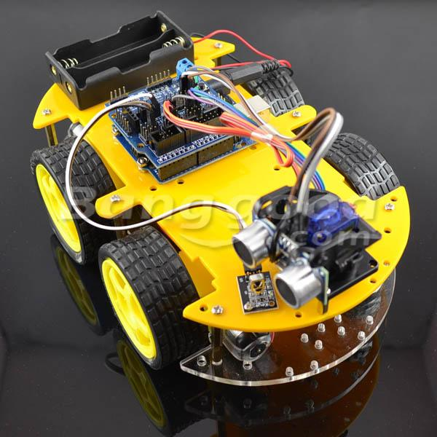

# **Arduino Robot eBOT Z Smart Car Robot Chassis Bundle DIY Everything Inc.(New USA)**

$84.99 + $13.52

<http://www.ebay.com/itm/Arduino-Robot-eBOT-Z-Smart-Car-Robot-Chassis-Bundle-DIY-Everything-Inc-New-USA-/261955002264?hash=item3cfdbc1f98>

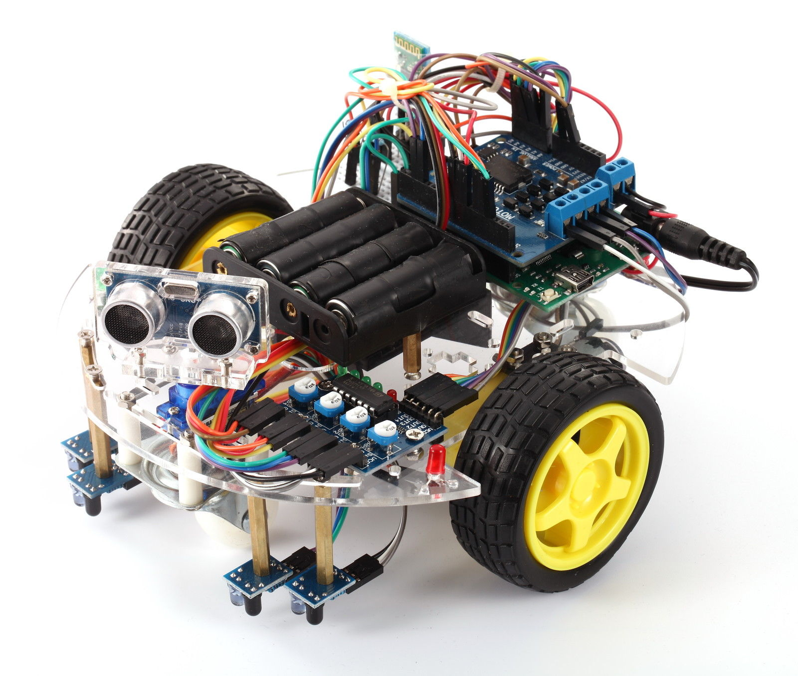

# **2WD Robot Raider Car Kits Compatible With Arduino**

$27.98

<http://www.ebay.com/itm/2WD-Robot-Raider-Car-Kits-Compatible-With-Arduino-/280844351548?hash=item4163a0b83c>

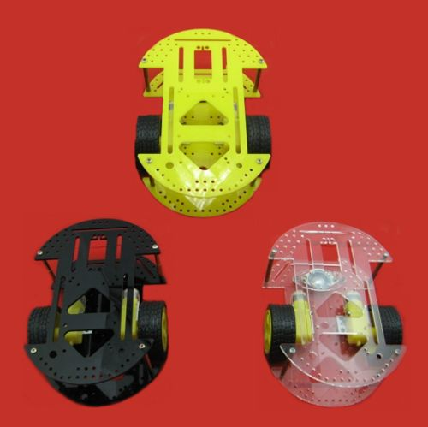

# **Robot Learn Kits Robot Kits Smart Turtle Car Wireless for Arduino new**

$93.00 + $1.95 shipping

<http://www.ebay.com/itm/Robot-Learn-Kits-Robot-Kits-Smart-Turtle-Car-Wireless-for-Arduino-new-/381259987803?hash=item58c4ddbb5b>

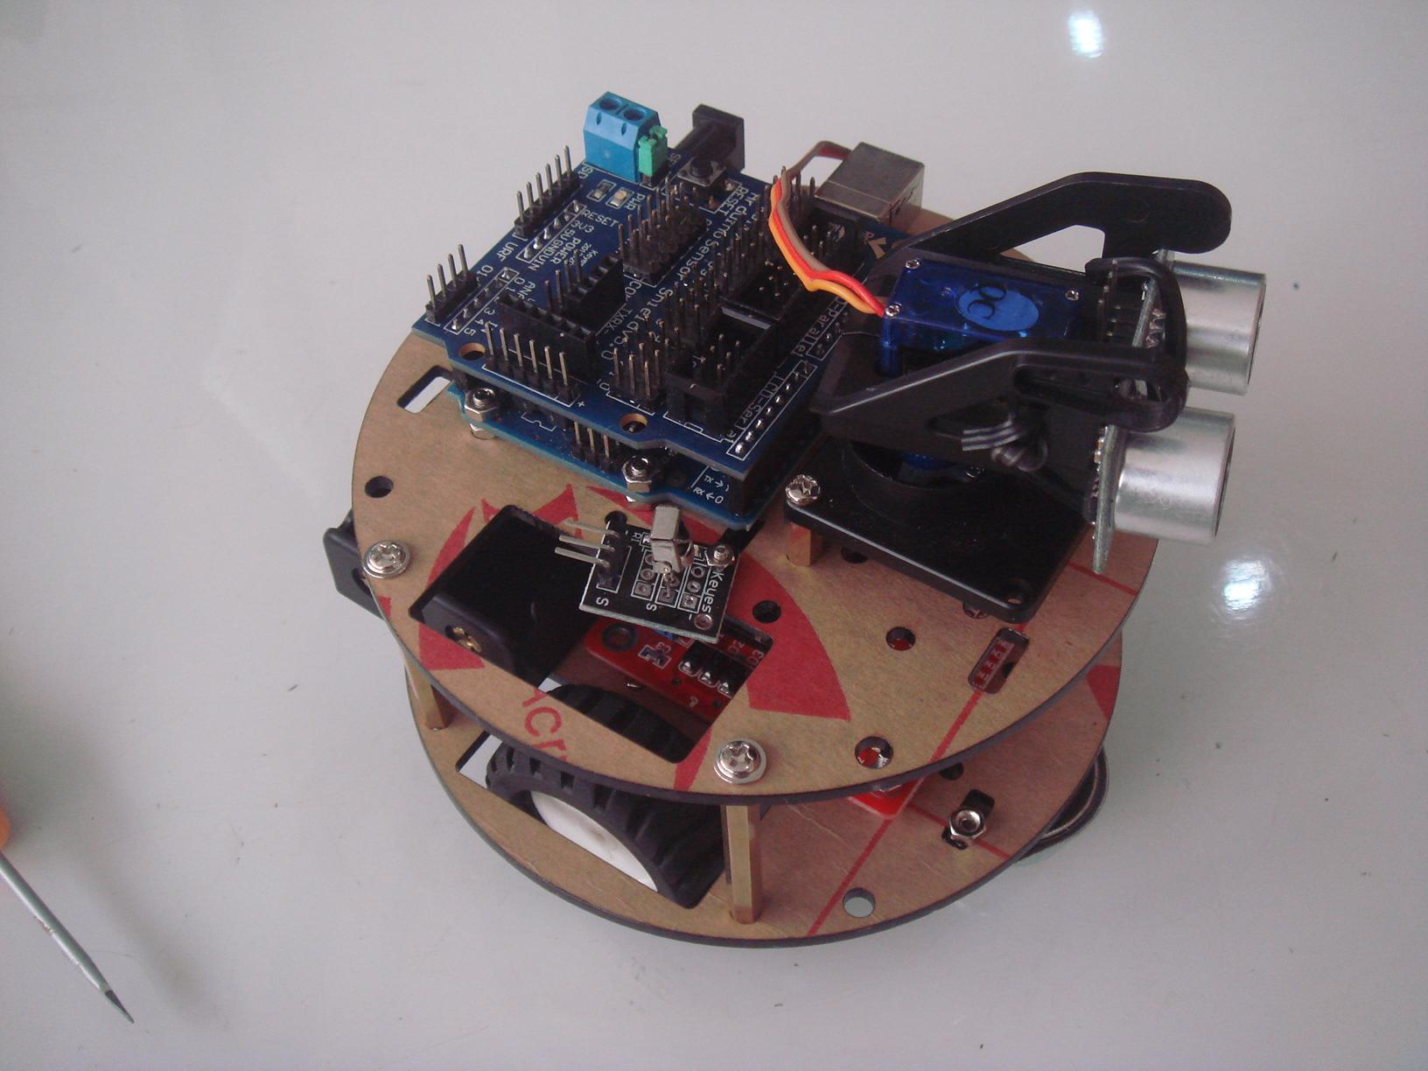

# **Intelligent Car Chassis Two Drive Double Layer Smart Car Tracing Car K-002**

$29.96

<http://www.ebay.com/itm/Intelligent-Car-Chassis-Two-Drive-Double-Layer-Smart-Car-Tracing-Car-K-002-/131396210975?hash=item1e97d3111f>

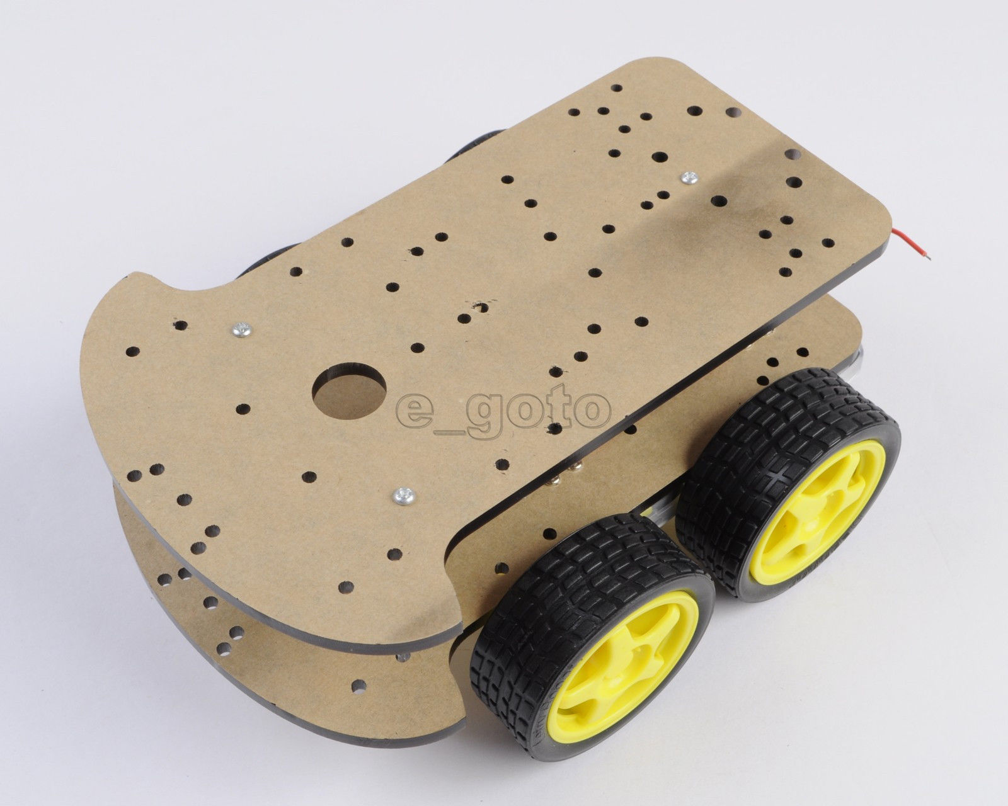

# **AS-2WD Car Aluminum Mobile Robot Arduino Mobile Platform Car Chassis**

$66.90

<http://www.ebay.com/itm/AS-2WD-Car-Aluminum-Mobile-Robot-Arduino-Mobile-Platform-Car-Chassis-/261710357028?hash=item3cef272224>

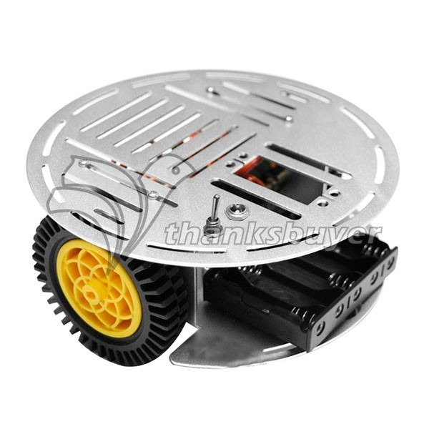

# **AS-2WD Car Aluminum Mobile Robot Motor Drive Mobile Platform Car Chassis**

$47.90

<http://www.ebay.com/itm/AS-2WD-Car-Aluminum-Mobile-Robot-Motor-Drive-Mobile-Platform-Car-Chassis/251766579273?_trksid=p2047675.c100005.m1851&_trkparms=aid%3D222007%26algo%3DSIC.MBE%26ao%3D1%26asc%3D32933%26meid%3Dcfd653d6b7094b2cbd28d48fb6fbdff0%26pid%3D100005%26rk%3D1%26rkt%3D6%26sd%3D261710357028>

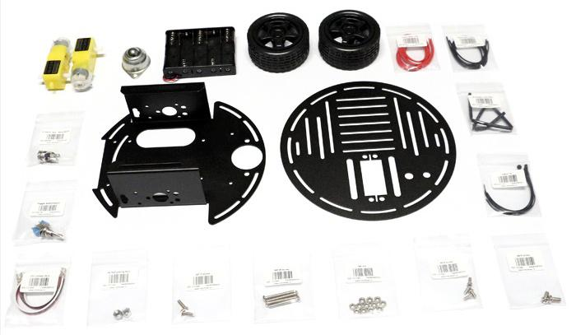

# **Magician Chassis 4WD Mobile Robot**

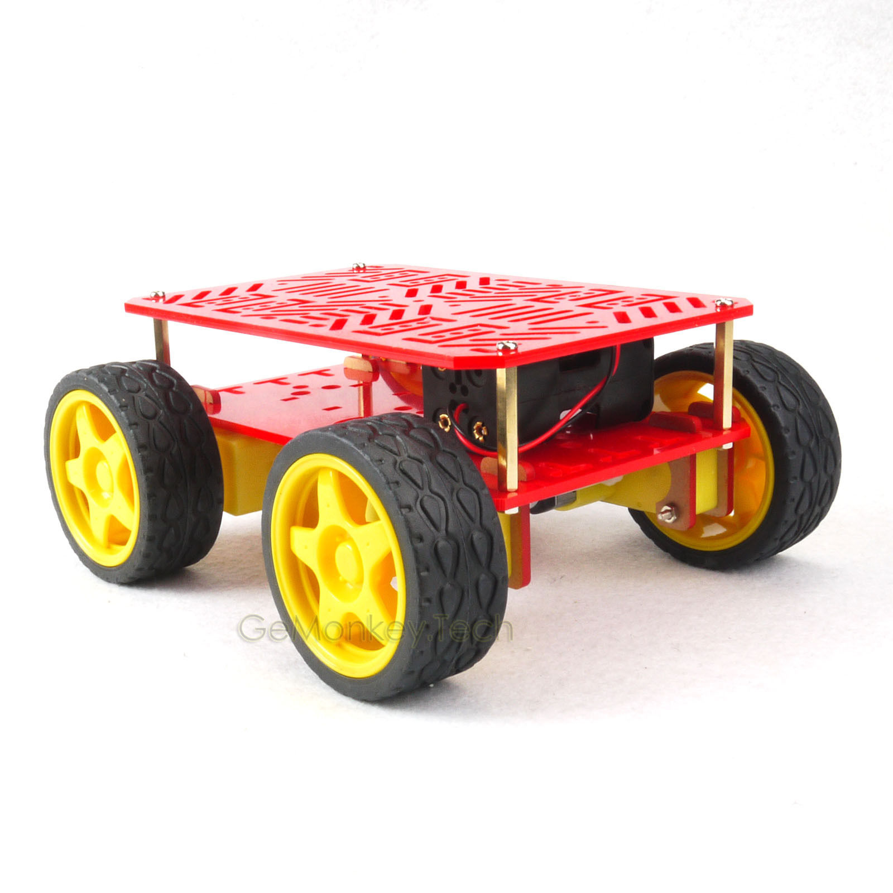

<http://www.ebay.com/itm/4-Wheel-Drive-Mobile-Robot-Platform-Arduino-Compatible-/170700901941?hash=item27be910e35>

# **Arduino Robotics Beginners DIY Shield Bot Chassis Kit With Mini USB Charge**

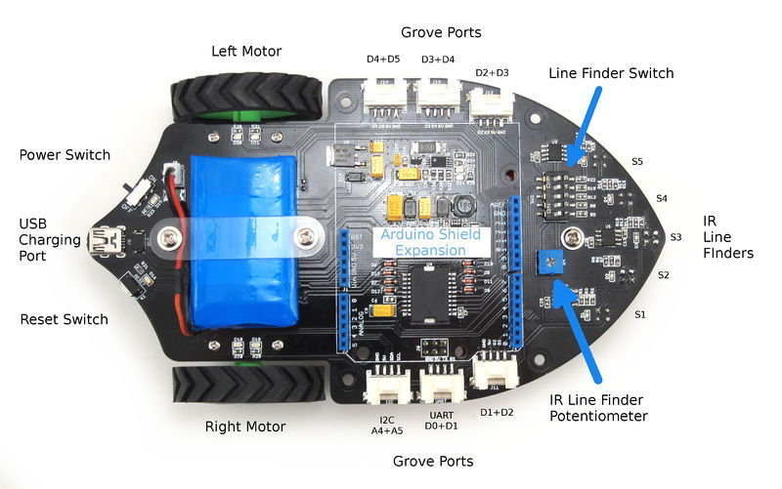

<http://www.ebay.com/itm/Arduino-Robotics-Beginners-DIY-Shield-Bot-Chassis-Kit-With-Mini-USB-Charge-/121307131795?hash=item1c3e77ef93>

# **Dagu Hi-Tech RS014-USB 2-in-1 Mini Robots Kit Arduino-compatible Unassembled**

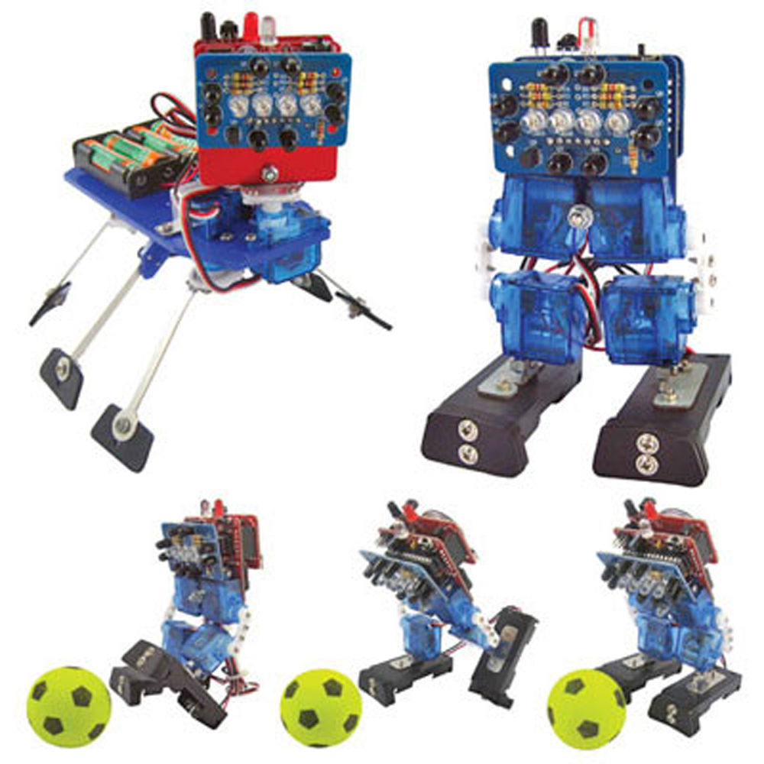

<http://www.ebay.com/itm/Dagu-Hi-Tech-RS014-USB-2-in-1-Mini-Robots-Kit-Arduino-compatible-Unassembled-/111271992116?hash=item19e853db34>